Ideation Phase

Define the Problem Statements

|  |  |
| --- | --- |
| Date | 22 October 2022 |
| Team ID | PNT2022TMID17751 |
| Project Name | INDUSTRY-SPECIFIC INTELLIGENT FIRE MANAGEMENT SYSTEM |
| Maximum Marks | 2 Marks |

Customer Problem Statement :

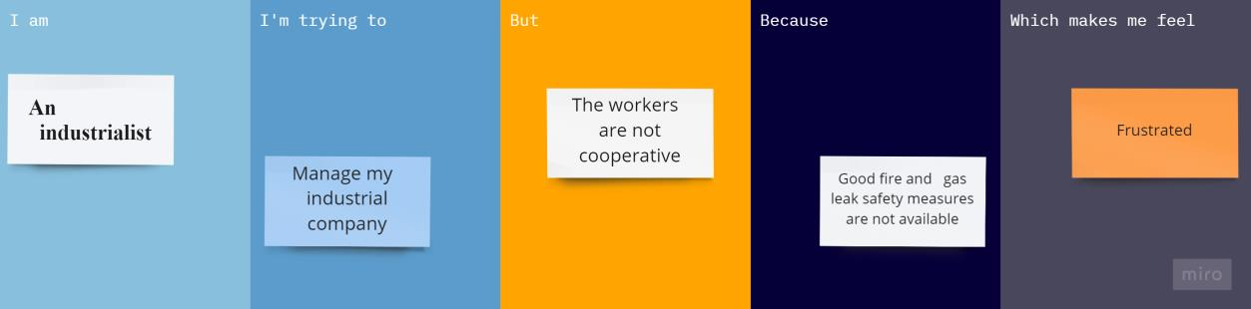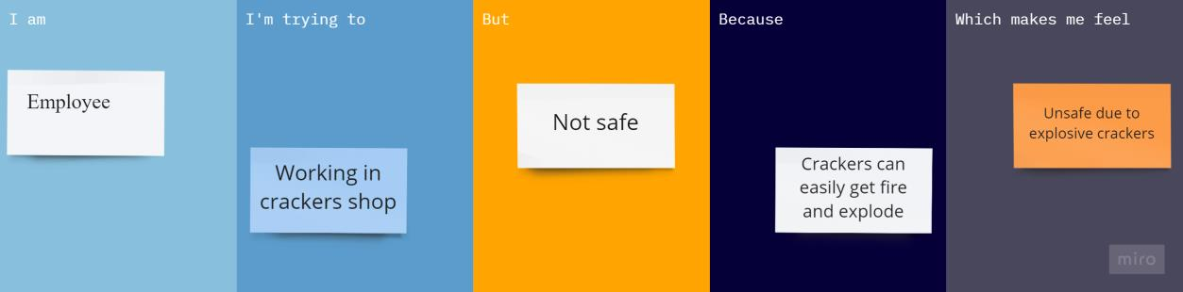

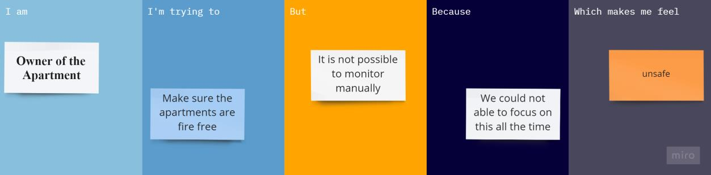

|  |  |  |  |  |  |
| --- | --- | --- | --- | --- | --- |
| **Problem Statement (PS)** | **I am (Customer)** | **I’m trying to** | **But** | **Because** | **Which makes me feel** |
| PS-1 | An industrialist | Manage my industrial company | The workers are not  cooperative | Good fire and gas leak safety measures are  not available | Bad about the situation |
| PS-2 | Employee | Working in crackers shop | Not safe | Crackers can easily get fire  and explode | Unsafe crackers can cause damage |
| PS-3 | Owner of the apartment | Make sure the apartments are fire free | It is not possible to monitor  manually | We could not able to focus on this all the  time | unsafe |